

fdsfdsfdsfdsfsB]jldshfsdhf
advice
work
skills
careers

support
opportunities
^{Mobile drop}

^{in service}

^{by}

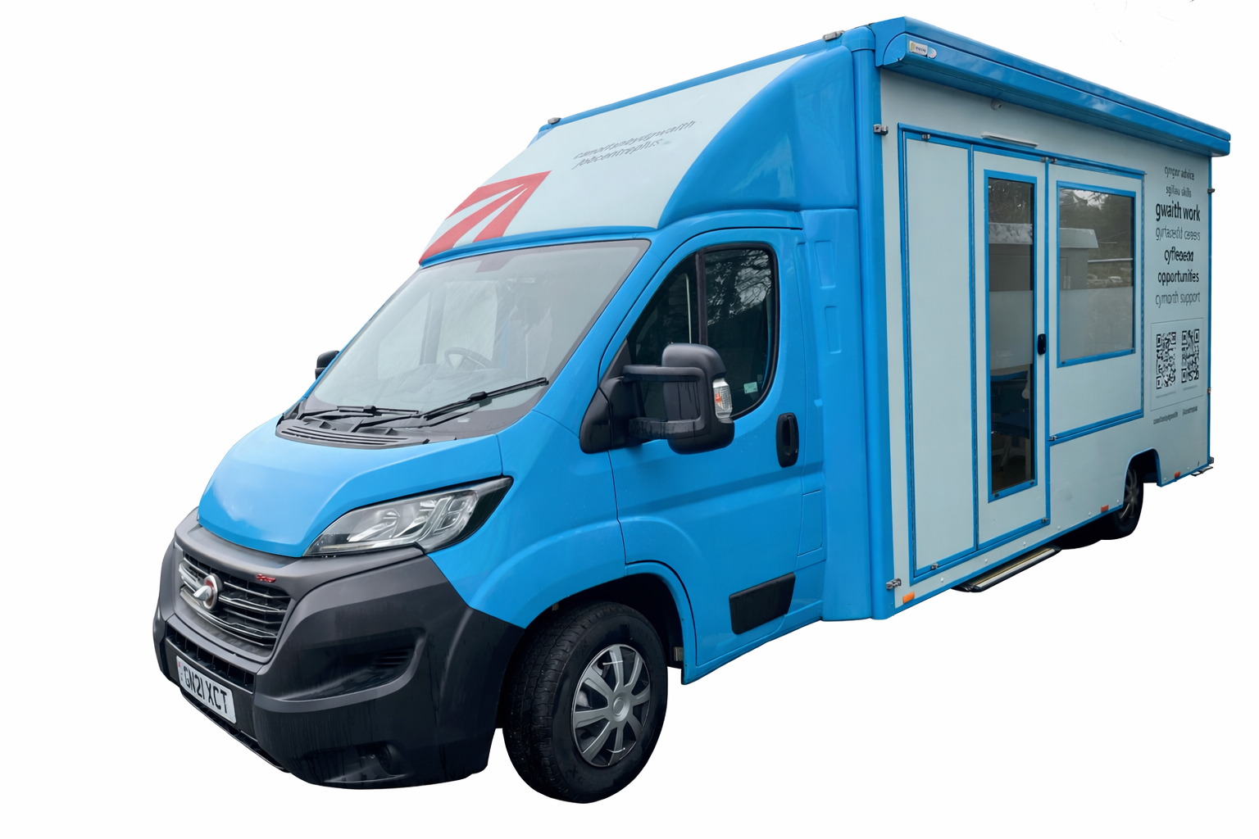

WE CAN HELP WITH:

• Local job opportunities
• CV support
• Training and courses
• Career change
• Interview preparation
• General benefit advice/signposting
• Options when leaving education
• Apprenticeships
• Working with a health condition
• Work search guidance
• Job application assistance

Where: Hirwaun Village Hall, High Street, Hirwaun, CF44 9SL

When: Every Friday 10am-2pm

For any benefit payment enquiries, please contact us by phone or visit your nearest Jobcentre.

